Stamford University Bangladesh



Lab Report

Course Title: Software Engineering Sessional

Course Code: CSI 331

Group Name: Minds Game

Project name: Kachabazar.com

Submitted to Submitted by

Course Teacher Name:

Name: Ashfaq Ali Shafin 1. Md. Asaduzzaman Masum

Designation: Lecturer ID: CSE 06307433

2. Taufiq Anam Fahim

ID: CSE06307436

3. Md Shamim

ID: CSE 06307456

4. Abid Ahmed

ID: CSE 06307455

Introduction:-A Data Flow Diagram (DFD) is a traditional way to visualize the information flows within a system. It shows how information enters and leaves the system, what changes the information and where information is stored. The purpose of a DFD is to show the scope and boundaries of a system as a whole. It may be used as a communications tool between a systems analyst and any person who plays a part in the system that acts as the starting point for redesigning a system.

Goals of Data Flow Diagram:-

* Graphically represents the flow of data in a business information system.
* DFD describes the processes that are involved in a system to transfer data from the input to the file storage and reports generation
* Create or obtain an accurate and reliable narrative.
* From the narrative, create a complete table of entities and activities.
* Draw a context diagram with external entity boxes by distinguishing carefully between internal and external entities.

Decomposition of Data Flow Diagram:-

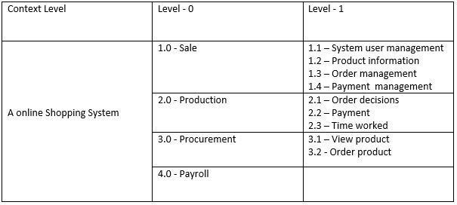

Context Level:-

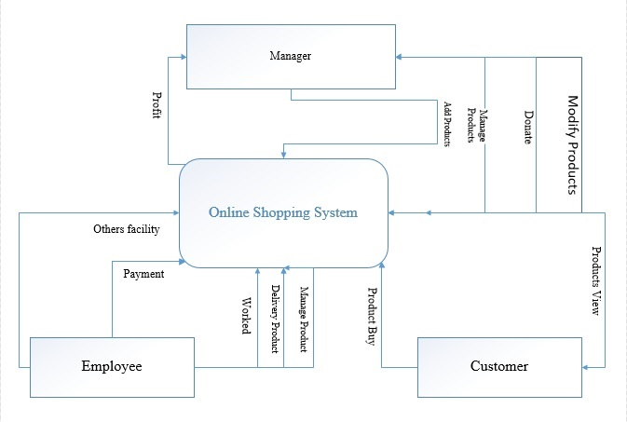

Level 0 Diagram:-

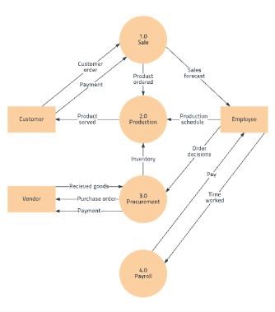

Level 1 Diagram:-

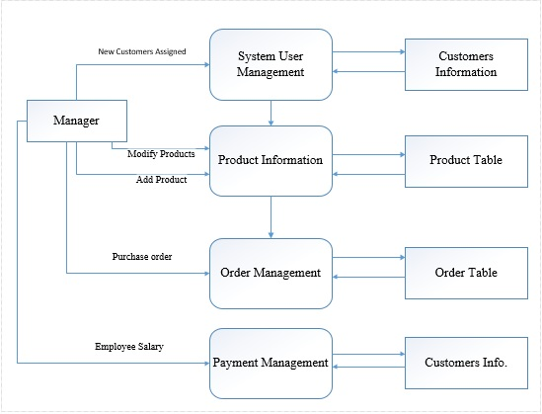

Level 1 Diagram:-

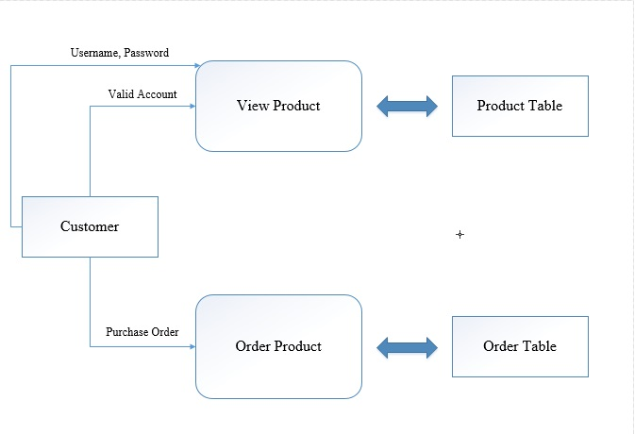

Level 1 Diagram:-

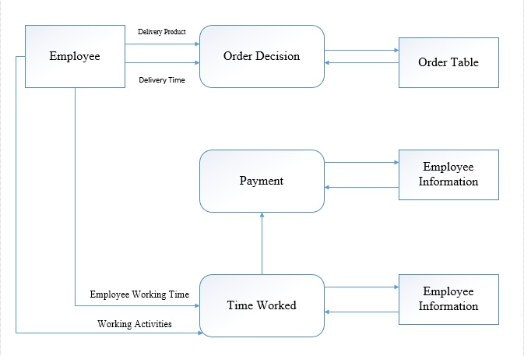

Conclusion:- It ensures we have a tight, well-defined and efficient data flow model, which will become the basis for the rest of the procedure. However we must ensure, when we are adding or deleting items to or from our data flow model, that we continually validate it to make sure we are not introducing errors. We generally find this to be the norm, especially where there already is an up-to-date, working computer system in place.